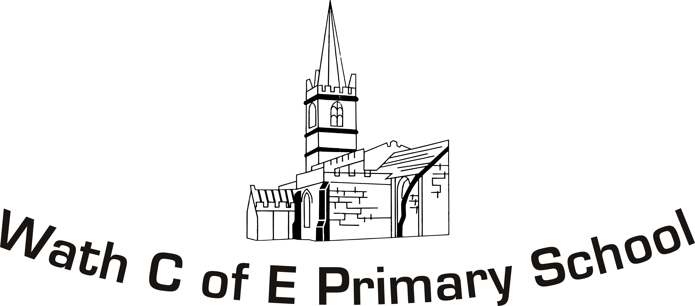
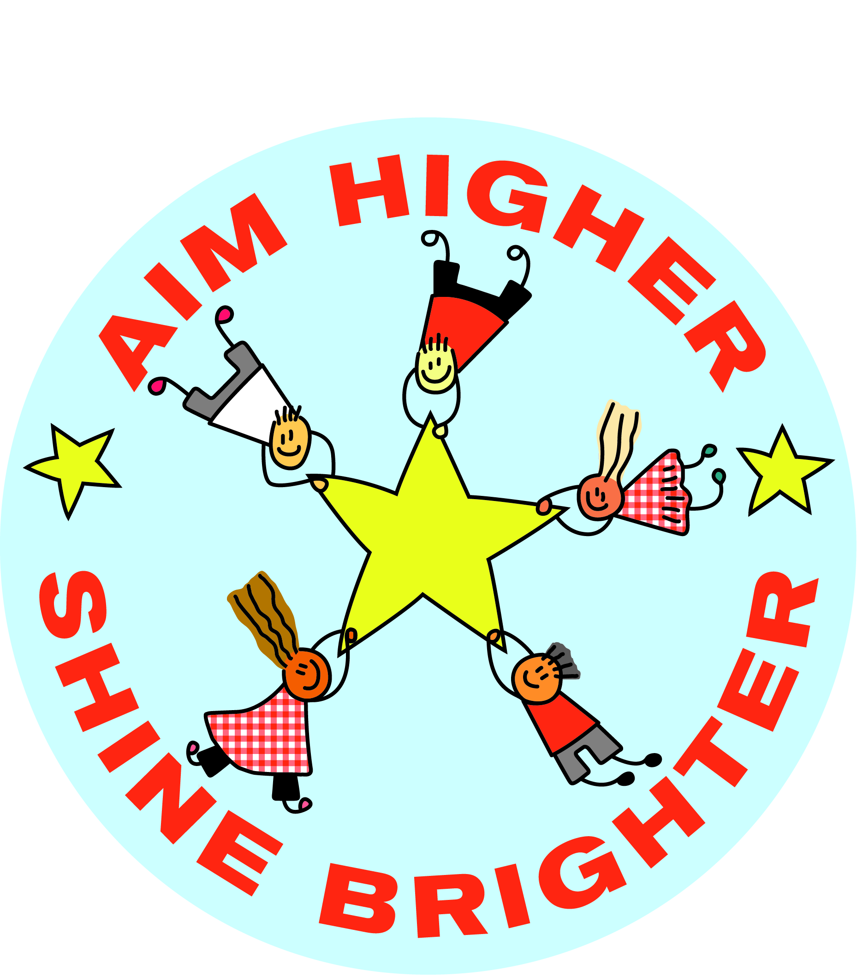

Thursday 4th June 2020

Dear Parents and Carers

As you know schools have been asked to welcome back a wider group of children from the start of June. The James Montgomery Academy Trust decided in the interests of the safety of pupils, their families and staff that a greater amount of time was required before allowing pupils to return more widely. After a week, the trust are satisfied the conditions are now safer to open our schools more widely. Due to this, from 08.06.20, schools across the trust will now open more widely. We appreciate your patience during this period and understand the uncertainty of the last few weeks will have presented significant challenges to families. This isn’t something we wanted however the trust and individual schools take the safety of the children, families and staff very seriously and this directed our thinking. As a result on this sharp focus on safety, school will be very different when the children return.

- Vulnerable children and children of key workers who have already applied and been given a place in school will continue to attend school as they have done since the 1st of June.
- Other children from F1, F2, Year 1 and Year 6 will only attend school from their year group’s start date in the table below and only if they have been notified by school that their child/children have a place.
- Any new requests into either the key worker groups or returning year groups will require a five working days’ notice before a child starts. Places can only be offered if there is space after a risk assessment of capacity by the school has taken place.
- A large increase in the key worker/vulnerable group would mean school would have to consider reducing capacity in Year 6, Year 1, F2 or F1 so that the integrity of each bubble could be maintained.
- For key worker or vulnerable children they will be in a bubble with children from a range of year groups.
- When classes return [F1, F2, Y1 and Y6] vulnerable or keyworker children in these year groups will move into their class group.
- The children will be in bubbles of 13 children or less.
- DFE social distancing guidelines advise that children should work, play and eat within this group bubble and not interact with any other children.
- Returning year groups will be grouped with their own class unless the numbers in that class exceed 13.
- Classrooms will be arranged with social distancing in mind with the children working largely at single desks with equipment for the classroom they will use only themselves.
- Playtimes and dinnertimes will be with the bubble children and play equipment will be used only by this group of children.
- Your child must be dropped off/collected in the correct place and at the correct time to ensure social distancing with the one adult doing this following the one-way systems marked by cones. Please don’t wait on the school grounds or use normal times as they won’t apply.
- It is imperative that parents and carers abide by the rules and protocols set out in school in the updated parent code of conduct on the school website. The social distancing measures we have put into operation to protect staff and pupils must be observed by all. Unfortunately if parents, carers or visitors to the school setting fail to observe the Covid secure protective measures and conditions in place they may lose their child's place in our school setting.
- Children can have a school dinner ordered in the same way as before school closed and this will a choice of three different sandwiches. Alternatively, packed lunches can be brought.
- All provision at school will close by 12.10pm on Fridays in line with other trusts schools to allow time for rigorous cleaning. Children can still order a packed lunch on this day and take it home if families wish to do this.
- The link here outlines school guidance in case of a confirmed case of Covid-19. Our school will follow this like all schools nationally.
- https://www.gov.uk/government/publications/closure-of-educational-settings-information-for-parents-and-carers/reopening-schools-and-other-educational-settings-from-1-june

So we can manage children’s return safely, this will happen gradually as mapped out in the table below, including drop off and pick up locations and times. This is the case at other James Montgomery Academy Trust Schools so the transition can managed. The children will need to be in school uniform as we are returning to school but the most important thing is you are able to clean the children’s clothes for the next day. If this means they don’t have uniform occasionally, this is understandable. Children can bring a water bottle which they will keep on their own table but must be taken home each day and washed. We will send further information if we want children to bring PE kits in the future but that is not necessary currently.

Group | Return to school date | Drop-off location/time | Mon – Thurs  Pick-up location/time | Friday pick-up  location/time
Key workers & vulnerable families | 01.06.20 | Green gate at the rear of school - 8.55 to 9.05 | Green gate at the rear of school – 3.05 | Green gate at the rear of school – 11.55am to 12.05pm
Foundation 1  [Morning only] | 08.06.20 | Am – 9am at the main front entrance | Am – 11.45 at the main front entrance | Am – 11.45 at the main front entrance
Foundation 2 | 08.06.20 | Green gate at the rear of school – 9.05 | Green gate at the rear of school – 2.55 | Green gate at the rear of school  11.45 to 11.55
Year 1 | 11.06.20 | 8.50 to 9am at the main front entrance | 3pm at the main front entrance | 12pm at the main front entrance
Year 6 | 16.06.20 | Green gate at the rear of school – 8.45 | Green gate at the rear of school – 3.15pm | 12.10pm Green gate at the rear of school

If you have any questions to ask in relation to this letter, please contact school on 01709 760471 or by emailing the school address which is school@wce.jmat.org.uk.

Yours sincerely

Paul Beevor
Headteacher

